Description

Our Tuff Face Insulation Blanket is a wide-width condensation blanket consisting of a white, smooth, cross laminated wall insulation blanket, designed specifically for agricultural construction in new or retrofit applications. It is often referred to as ‘peck proof’ because of its bird resistant qualities.

By combining the formaldehyde-free JM Condensation Control Blanket® with the outstanding UV protection, elongation, and barrier characteristics of Valeron® polyethylene film, we have fabricated a product that is top of the line.

Properties | Test Method | Tuff Face
Tensile Strength (psi) | ASTM D-882 | 7200
Puncture Propagation (grams) | ASTM D-2582 | 3500
WVTR  (gm/100 sqin/24hrs@100F) | ASTM E-96 | 0.12
Yield (lbs/msf) | Continuous  gauging | 16.3

Tuff Face Insulation is available in custom length rolls that are 3’, 4’, or 6’ wide with the convenient option of having one 6” or two 3” tape tabs.

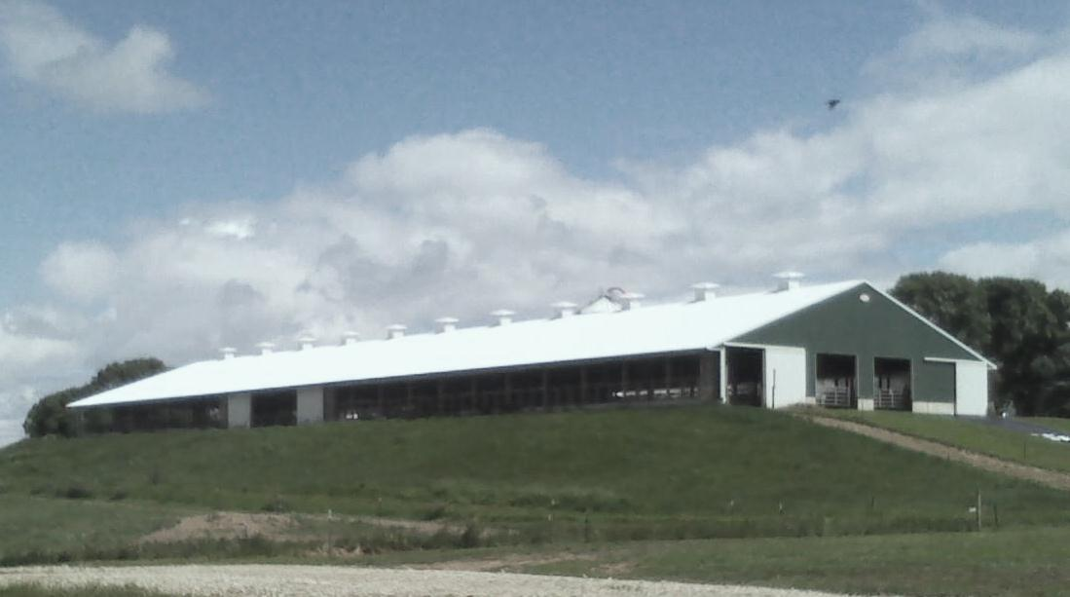

When a superior condensation blanket is required, turn to our Tuff Face Insulation Blanket.

